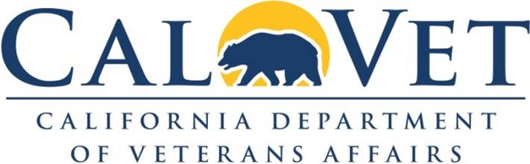

Mission: We strive to serve and honor all California veterans by connecting them and their families with their earned benefits through education, advocacy, and direct services.

Commodities list:
- PPE (masks, exam gloves, gowns, caps, booties)
- Prosthetics
- Hearing aids
- Medical supplies and furniture (e.g., hospital beds)
- Office supplies
- Cleaning supplies
- Auto parts and tools
- Water treatment chemicals
- Landscape and irrigation supplies

Services list:
- Pest control
- Security guard
- Temporary/relief medical or therapy staffing
- Confidential shredding
- Plumbing
- Physician, Dental, Dietician, Optometry, Pharmacy, Radiology, Ultrasound
- Hazardous and non-hazardous waste pickup and disposal
- Fire protection system testing, maintenance and repair
- Grease trap cleaning, pickup and disposal
- Beauty and barber
- Casket lowering device maintenance
- Dosimetry
- Elevator maintenance and repair
- Fire extinguisher maintenance
- Boiler and Chiller maintenance and repair
- Electrical system testing and repair
- Interpreting
- Janitorial
- Laboratory, medical
- LiveScan
- Portable latrine and wash station rental
- Commercial kitchen equipment maintenance and repair
- Tree maintenance
- Wheelchair repair
- Non-emergency medical transportation
- Water testing and treatment
- Window cleaning
- Automatic door repair or replacement
- Window repair

Construction:
- Asphalt repair
- Sidewalk repair
- Flooring replacement
- Fence repair
- Roof repair
- Exterior or interior painting

We are always looking for certified SB/DVBE firms who can provide services to any of our veterans homes; but, we usually have a difficult time locating firms that service our more remote (or more difficult to get to) homes, such as Barstow (San Bernardino County), Lancaster (LA County), Redding (Shasta County), Ventura (Ventura County), and Yountville (Napa County) and our cemeteries in Seaside (Monterey County) and Igo (Shasta County).

Here’s the url for our “doing business with CalVet” website: https://www.calvet.ca.gov/about-us/doing-business

Contact: Rose Skewis, rose.skewis@calvet.ca.gov

